1. 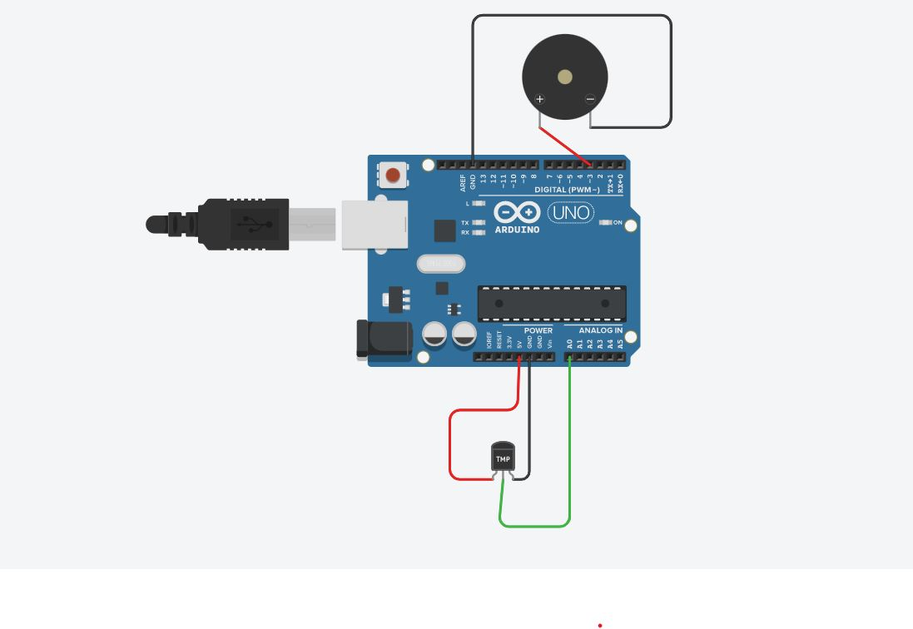**Arduino With Temperature Sensor and Buzzer :-**

* **Circuit Connections**

**Code:**

float sensorValue, Celsius;

void setup() {

Serial.begin(9600);

pinMode(A0, INPUT);

pinMode(3, OUTPUT);

}

void loop() {

sensorValue = analogRead(A0);

Celsius = (sensorValue*5000/1024)/10;

Serial.print("Celsius: ");

Serial.print(Celsius);

Serial.print("\n");

if(Celsius>60)

{

digitalWrite(3, HIGH);

}

else{

digitalWrite(3,LOW);

}

delay(2000);

}

***Output:***

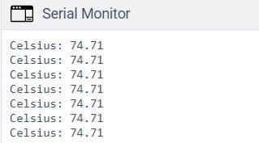

1. **Arduino With PIR Sensor :-**

**Circuit Connections:**

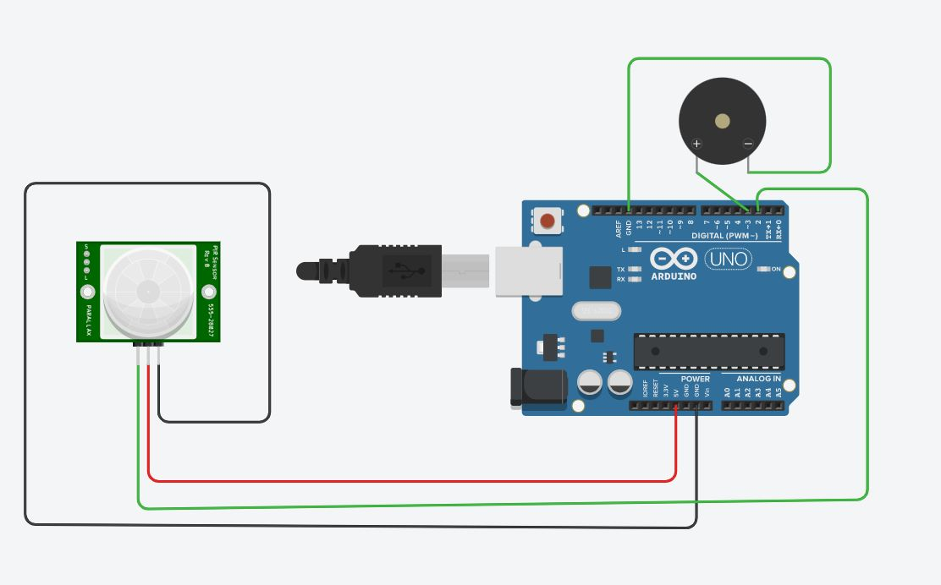

**Code:**

void setup() {

pinMode(2, INPUT);

pinMode(3, OUTPUT);

}

void loop() {

if (digitalRead(2) == HIGH)

{

digitalWrite(3, HIGH);

delay(100);

digitalWrite(3, LOW);

delay(100);

}

}